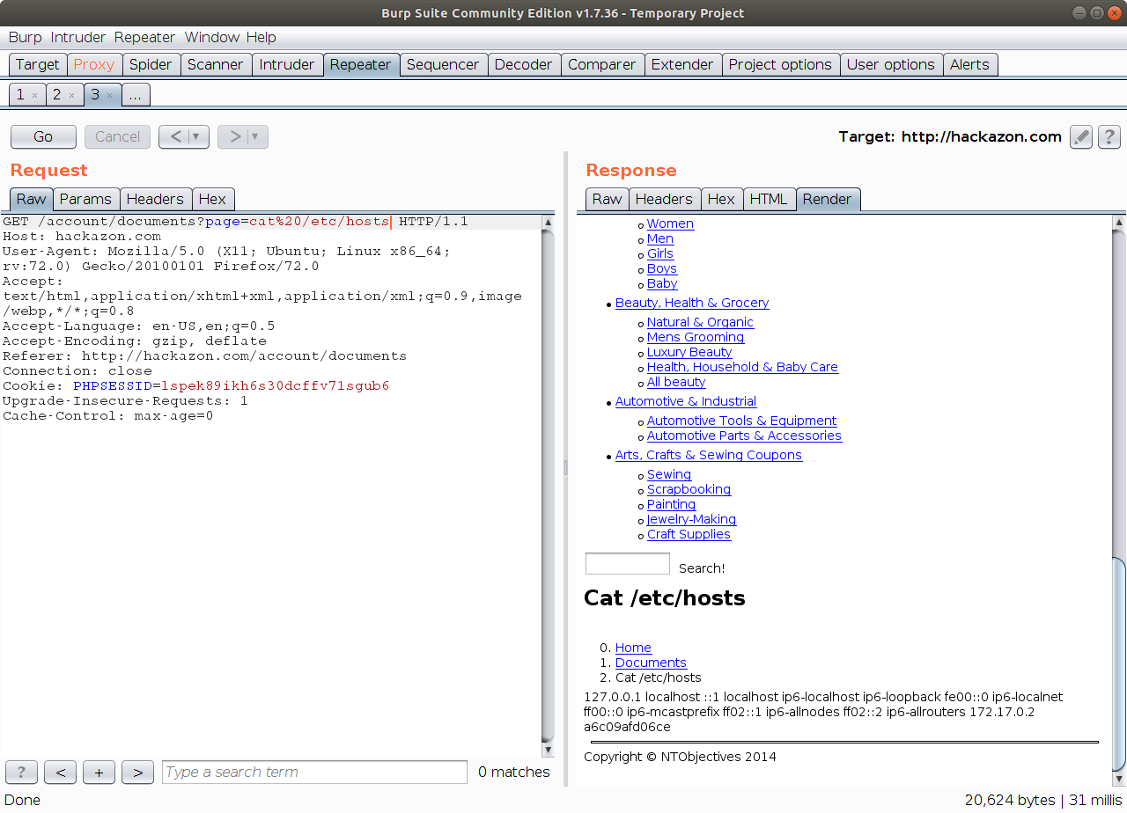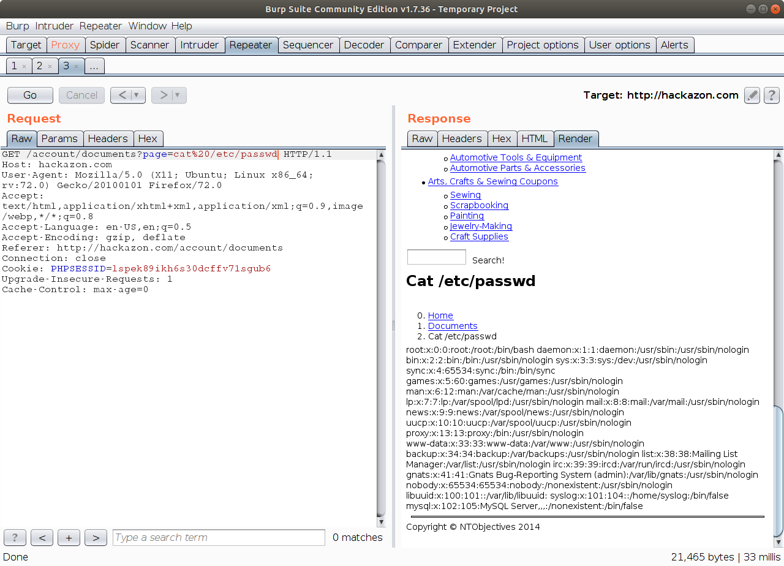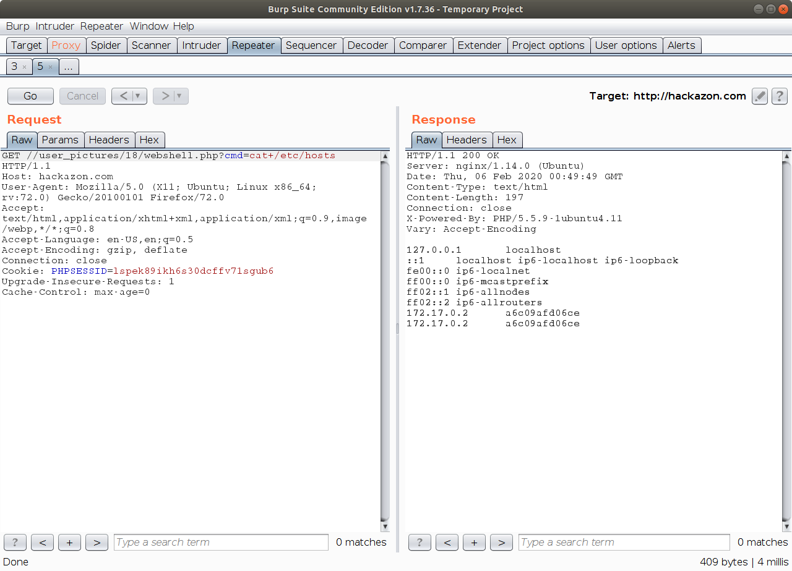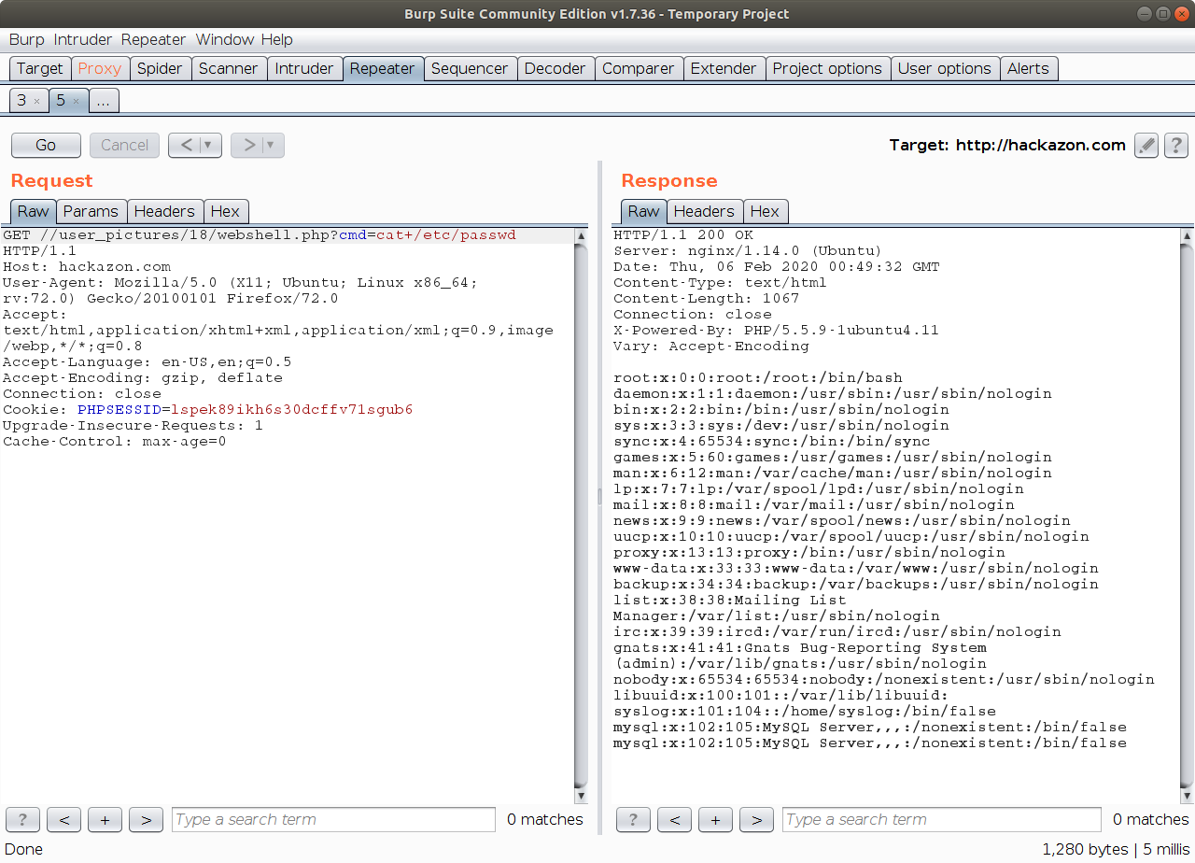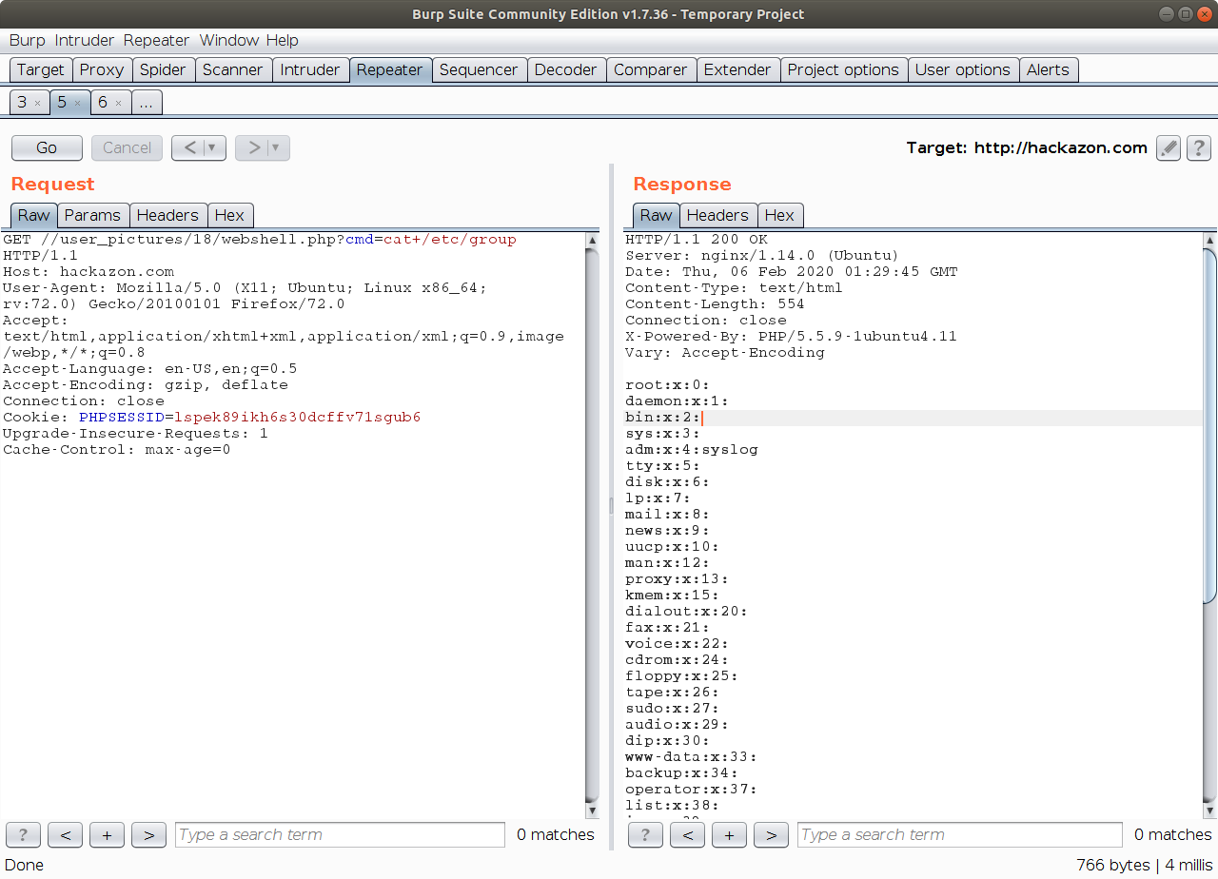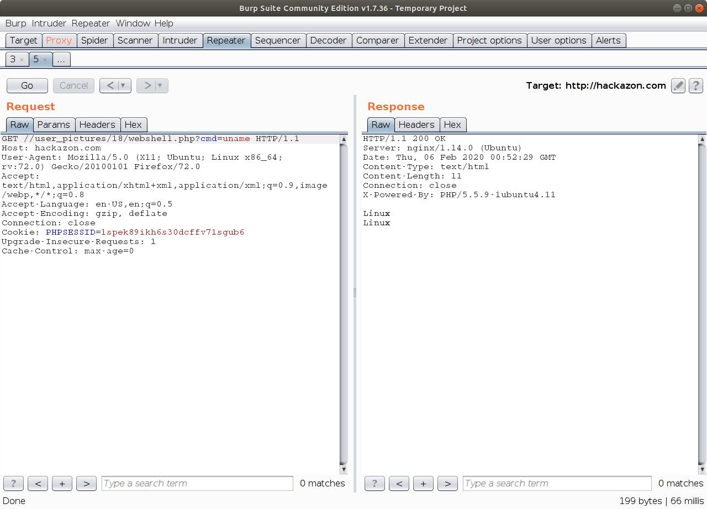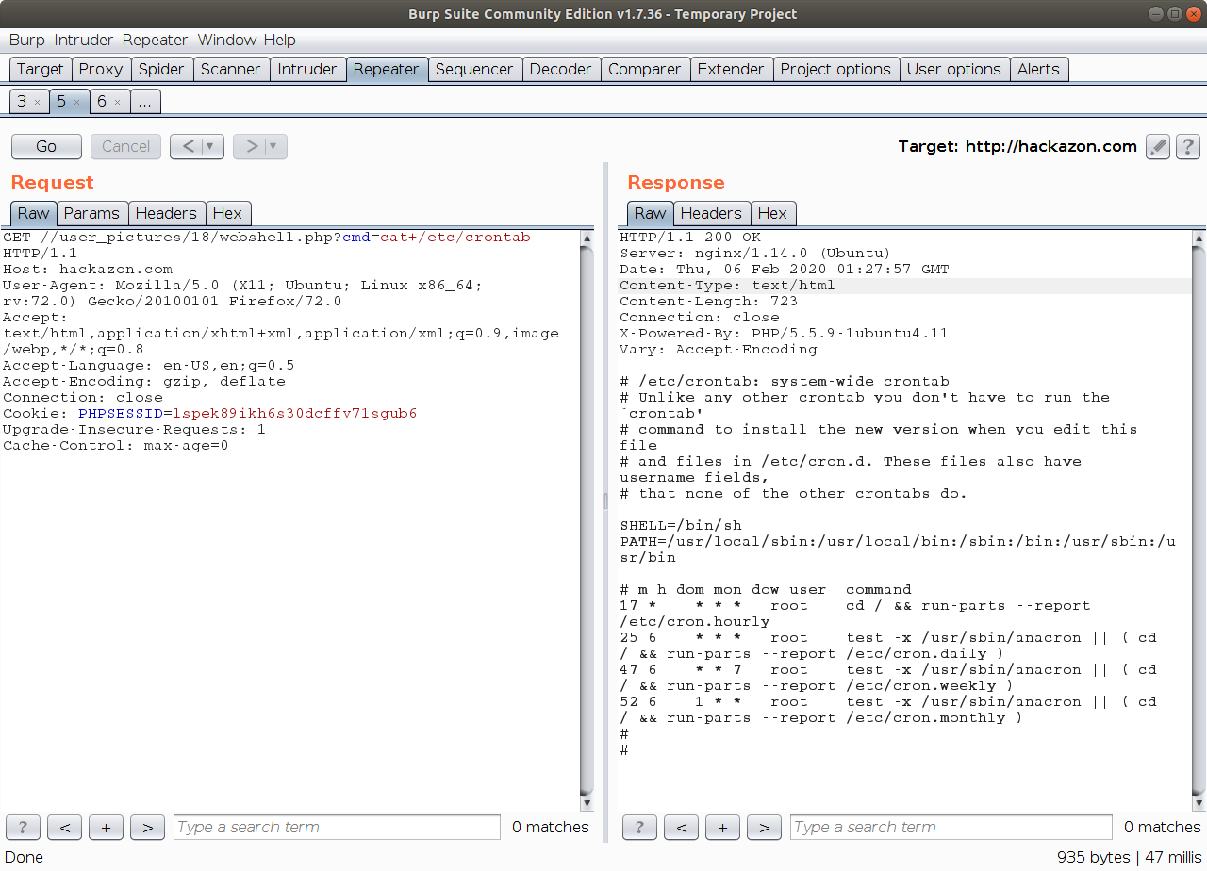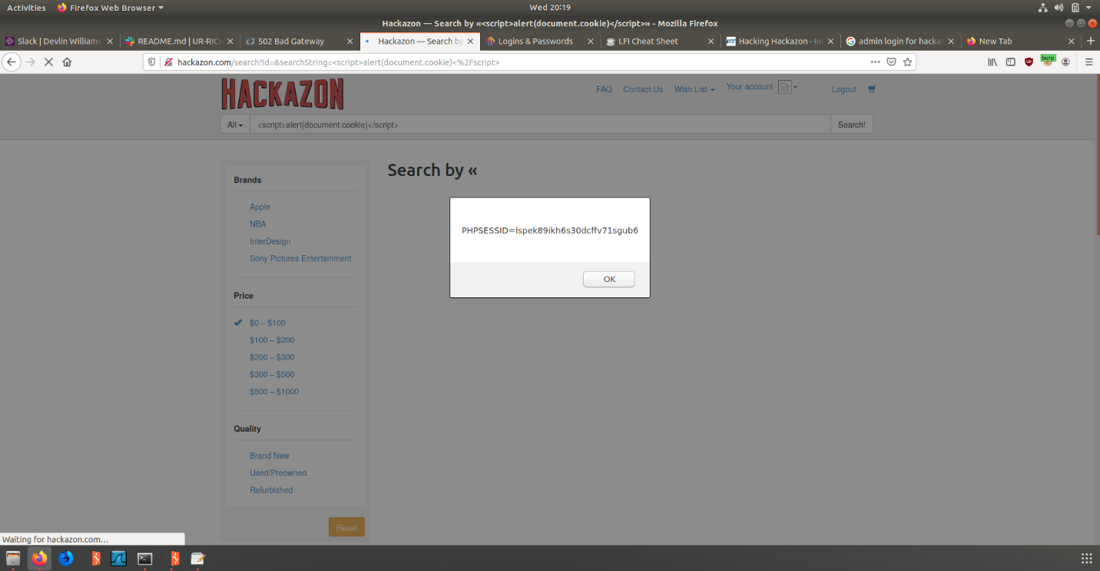

For part 1 I used URL manipulation in order to trick hackazon into giving me info from /etc/hosts and /etc/passwd

Here is the list of passwords

Here I typed cat /etc/passwd

Here I typed cat /etc/host

Here is the list of hosts

Here is the list of hosts

Here I typed cat /etc/host

For part 2 I uploaded a PHP webshell and used URL manipulation in the form of cmd=<input> in order to trick hackazon into giving me info from /etc/hosts, /etc/passwd, a list of groups, the distro, and any cronjobs.

Here is the list of passwords

Here I typed cat /etc/passwd

Here is the list of groups

Here I typed cat /etc/group

Here is the distro

Here I typed uname

Here is the list of cronjobs

Here I typed cat /etc/crontab

Here I typed <script>alert(document.cookie)</script>

For part 3 I used a javascript snippet in order to make my session ID appear in a popup window. This is also part of the challenge